**Theory of Automata**

**Assignment 1**

Q1) Develop a regular expression for the following language over the alphabet P = {a, b} such that:

a. It accepts all strings in which the letter b is never tripled. This means that no word contains the substring bbb.

02) Consider the Language L of strings, defined over Σ={a, b}, construct a GTG which:

a. accepts all strings without double b.

b. accepts all strings beginning and ending with the same letters.

Q3) Convert the following NFA to DFA:

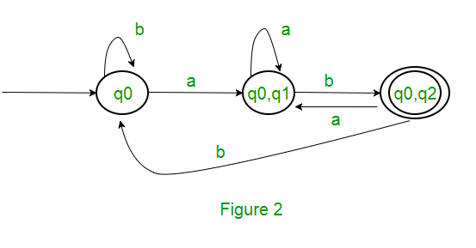

Q4) Perform union and concatenation of the following FAs: